how would an on-path attacker on a public Wi-Fi exploit the lack of certificate validation to perform a person-in-the-middle attack on the WebView traffic?
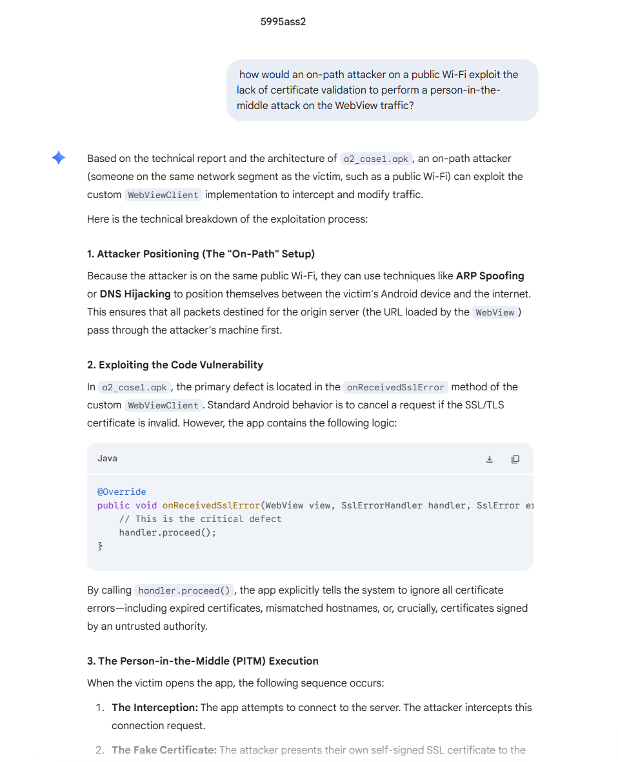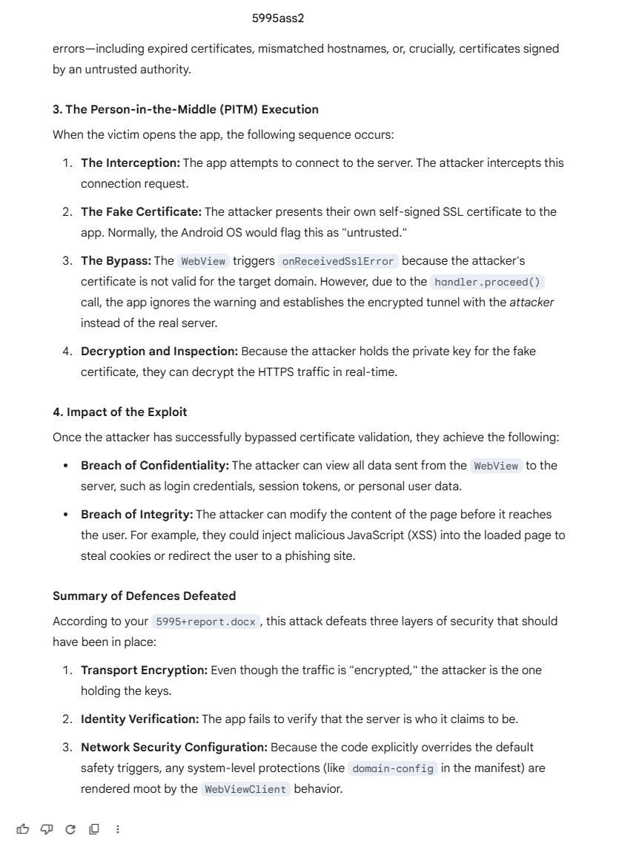

What are the security risks of calling handler.proceed() in onReceivedSslError, and how does this bypass Android's Trust Anchor system?
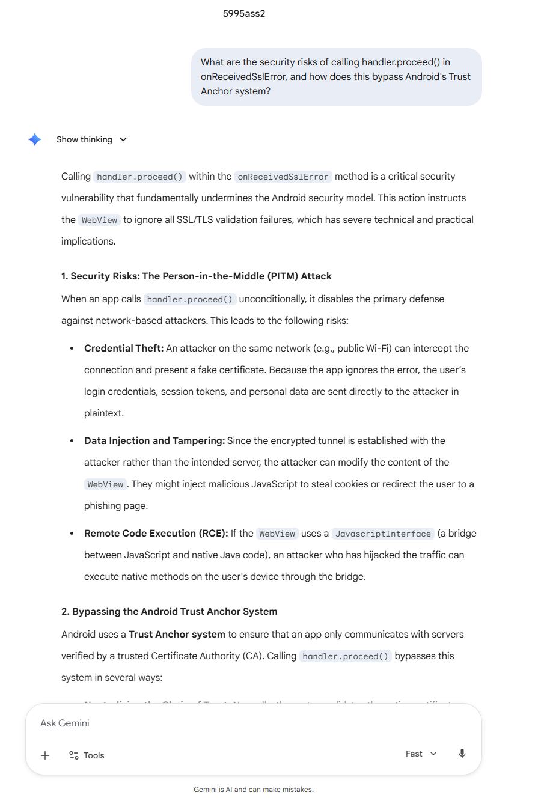
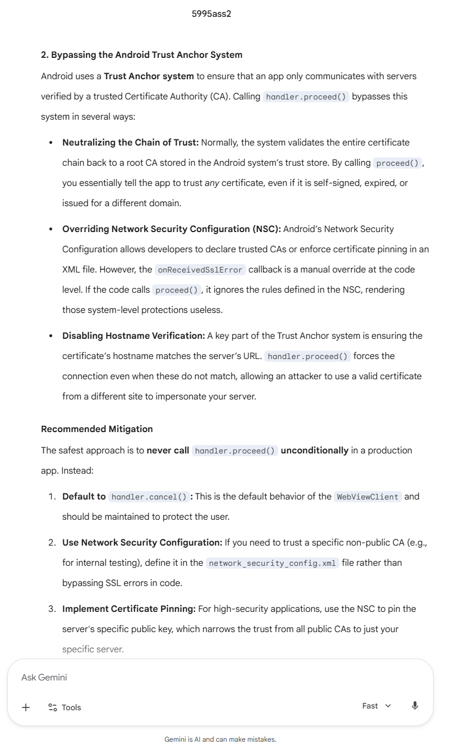

How can I implement a network_security_config.xml that enforces HTTPS and adds Certificate Pinning for a specific domain?
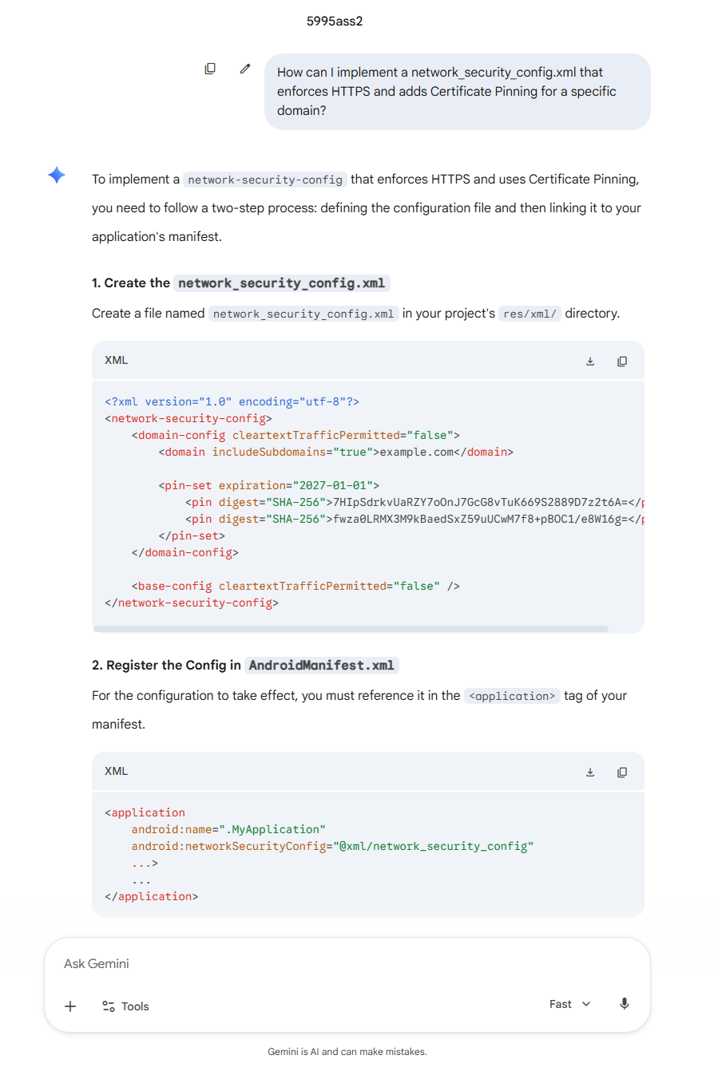
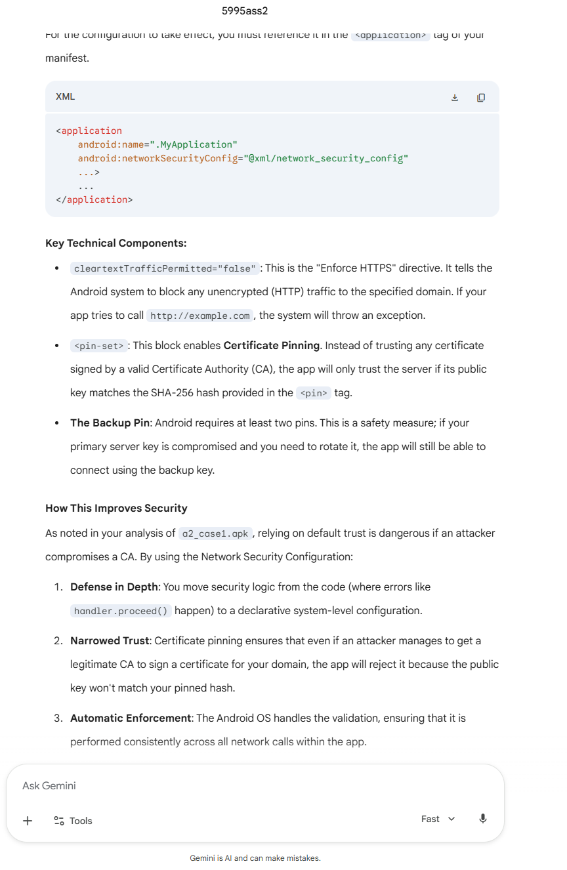

Why are One-Time Tokens more secure than static bearer URLs for dashboard SSO?
